Raspberry pi webcam initial setup - <https://www.youtube.com/watch?v=_uVaZalaSbI>

This tutorial will assume you have setup ssh, connected the camera to any usb port on the raspberry pi and have used a terminal before.

1. Installing the webcam

sudo apt install fswebcam

The software will now install

1. To verify the installation lsusb and the bus should appear

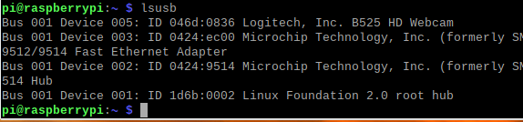



To verify the utilities are installed correctly use

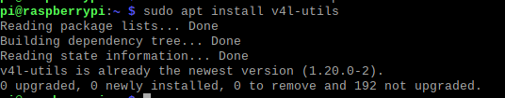

Pipe waits for key press and you can see all of the options available for your webcam.

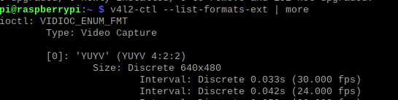

You will notice there is YUYV and MJPG support with screen size and fps with the Logitech camera used.

The next step is a test capture to make sure the webcam is working. Note the format -YUYV is required to capture. The save will be located in the home/pi folder, not the desktop.

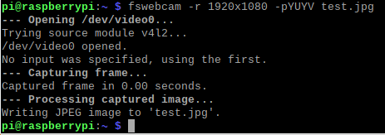

Here is my result for verification. Yours may differ 😊

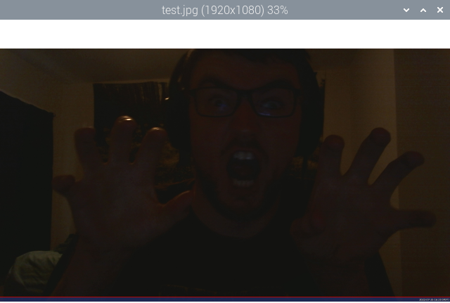

Note, streaming the webcam on YouTube requires advanced notice. You will have to set this up at least 24 hours in advance of when the homework is due.

